STUDENT Joseph Roper

Salford City College | [Company address]

BTEC National Extended Diploma in Creative Media Production

Unit 6: Critical Approaches

Unit 6 – Task 3

# Media Theory

## Hypodermic Needle

The “hypodermic Needle Theory” suggests that the media have a direct influence over the actions of its audiences. This theory became popular in the 1940’s and 50’s with the rise of radio and television in the media. An example of the needle theory was if a Coco Pops advert showed on television to children and stated “You should buy Coco Pops” children would immediately walk to the store and buy the product. This theory however is not correct as in a study during a general election the media slandered one of the candidates yet the voting patterns were not affect thus disproving the theory. If this theory however was true I would appear on television and tell the masses to buy my product causing me to become rich in the process.

[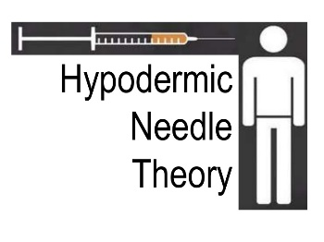](https://www.slideshare.net/HannahCharlesMedia/hypodermic-needle-theory-29639628)

## Uses and Gratification

Uses and Gratifications theory as developed by Bulmer and Katz suggests that audiences control the media they consume for five different reasons.

Information and education – These will include viewers who watch documentaries or news shows in order to gain information.

Entertainment – Audiences will watch programmes for entertainment and joy this could include shows like Harry Hill TV or Goggle Box.

Personal Identity – Audiences will watch a programme because they can relate to a characters ideals, characteristics or motivation and use them as a role model which they can mimic. An example of this can be with female teenager watching Kim Kardashian as they want to be like her.

Integration and social interaction – Viewers will watch a show because they enjoy it and can discuss it with their friends. For example people will watch Coronation Street so they can then later discuss what took place in the episode and how they feel about it to their friend.

Escapism – Audiences will consume media to escape their lives and place themselves into another, such as people will play Red Dead Redemption 2 so they can escape their world and live life as a lawbreaking cowboy.

I believe this theory to be right but I feel as if the five reasons are too broad as the entertainment reason can be expanded into other reasons such as someone could watch the show Love Island because they enjoy the drama created in the series another person could say they enjoy making fun of the contestants and that why they enjoy it.

To use this theory to my advantage I would make sure my product comes under one of these reasons so that media consumers will choose to consume it.

## Two Step Flow

Two step flow was an idea brought by Paul Lazarsfeld a sociologist, he theorized in correlation with the Hypodermic Needle Theory that audiences are not influenced directly by the media but we are instead take the word of opinion leaders as fact instead.

I believe the two step flow theory is true as this happens in everyday life such as if you watch an advert (media) for a new computer you wouldn’t really care as you can’t trust an advert because they are going to say their product is good no matter what however if a friend (influencer) that is good with computers told you that the computer shown in the advert was good and you should buy it, you would then start to consider buying the computer and start researching it.

To use the two step flow theory to my advantage I would pay influencers of my target audience to sponsor my product and advertise it to the masses.

[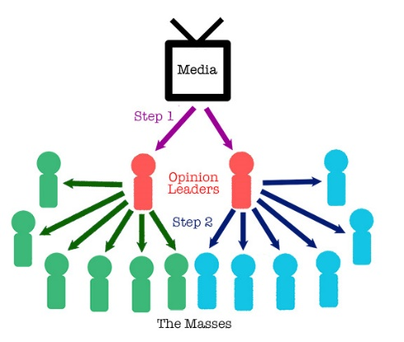](https://study.com/academy/lesson/two-step-flow-communication-model.html)

## Priming

Priming is a technique in media commonly used to promote or demote a product. The seller would say something bad for example smoking can cause lung cancer and then the seller would show the audience cigarettes now obviously after hearing that a normal person wouldn’t want a cigarette after hearing that news, if a seller would want to promote a restaurant they would show the audience pictures of delicious food and then people eating it to make the audience hungry and then the seller would present the audience with their restaurant. This technique might seem familiar as it is used a lot in every day adverts, for example, McDonald's advertising campaigns. Another example of this technique used in modern media is with Halifax’s recent ad campaign, in these televised videos they show a popular cartoon character setting up a bank account with Halifax or asking a Halifax employee about interest rates and various other things while showing these activities in a good light the advert will also have the cartoon characters make jokes. Halifax have used characters from the famous cartoons; Top Cat, The Flintstones and Scooby-doo, I believe these adverts are genius as it makes the consumer compare setting up a bank account with Halifax to the joy of watching cartoons in their youth.

[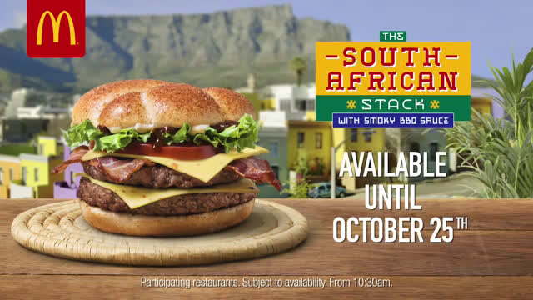](http://www.tvadvertsuk.com/restaurants-and-take-away/mcdonalds/mcdonalds-uk-tv-advert-the-south-african-stack-with-smoky-bbq-sauce-the-great-tastes-of-the-world-is-back-at-mcdonalds-im-lovin-it/)[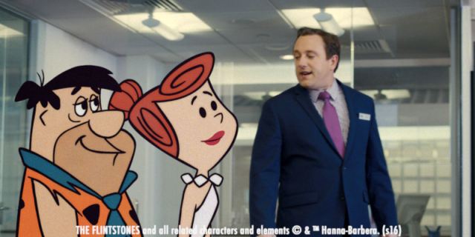](https://www.thedrum.com/news/2016/06/07/ad-day-flintstones-head-halifax-search-modern-bank)

## Spiral of Silence

The spiral of silence theory suggests that even in intense and difficult situations the minority will always conform to the majority. Basically peer pressure to do what a group wants will always win over individuality, we all have succumbed to the majority at some point from jumping into the sea, going on a rollercoaster or eating something even though you didn’t want to do those things because a group of people wanted you to do it you will because you want to fit in with the group and not disappoint them. Derren Brown did an experiment to prove the power of the majority indirectly helping the spiral of silence theory. In the experiment Derren Brown had a line of chairs with the a group of actors standing in front of them, he then had a member of the public come in to fill in a form with the others when a bell was pressed the actors would sit down and the bystander sat as well the bell went off again and the actors would stand up as the minority followed suit. The experiment then went on until there were no actors and only members of the public still following the rules that the actors set making them part of the majority.

Actors Public Actors Public

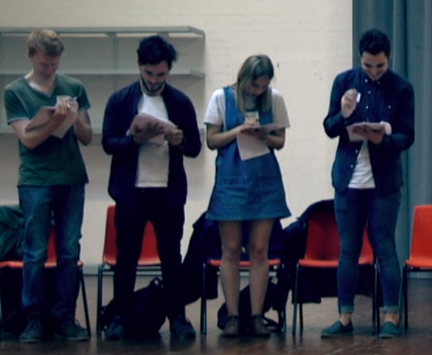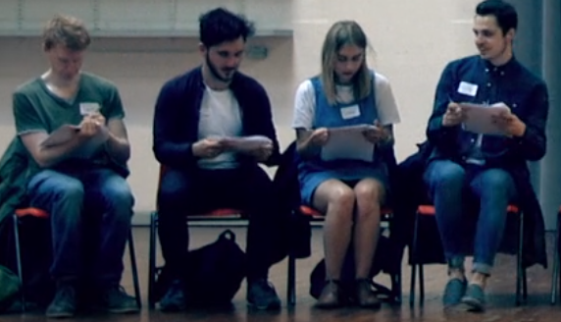

All of people below are members of the public and are not actors.

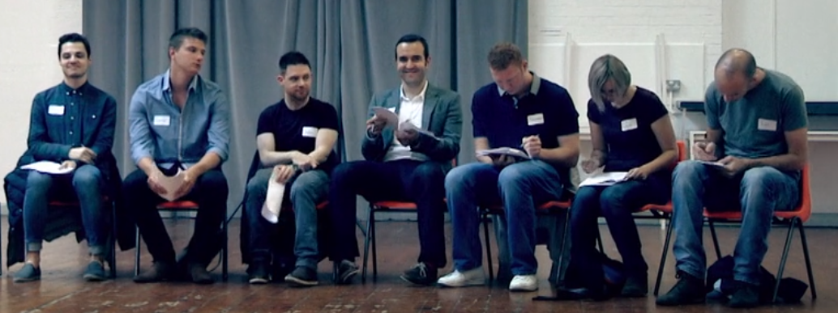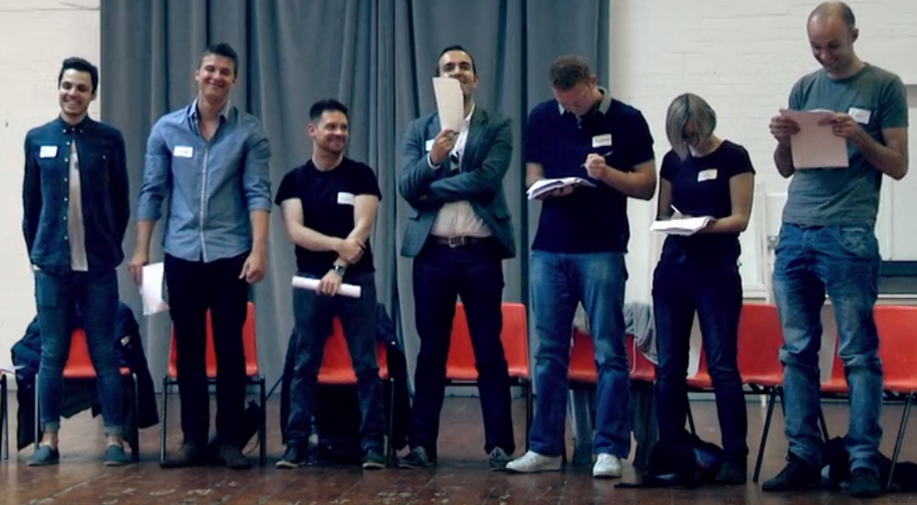

## Agenda Setting

The agenda setting theory suggests that the public mainly receive their important news from T.V. stations such as the BBC News meaning that the public will only hear and know about the problems that the BBC will cover. Therefore if the BBC didn’t focus a news segment for ongoing issues like global warming and instead focused on recent news such as a robbery the public would probably ignore that global warming is a thing and stop decreasing their carbon emissions. I believe this theory to be true as if there was a murder in Manchester and the news didn’t cover it hardly anyone would know about it. To use this to my own advantage if my product was to have an issue I would have the news not cover that part of my product and instead focus on positives for example half of the profits go to charity.

[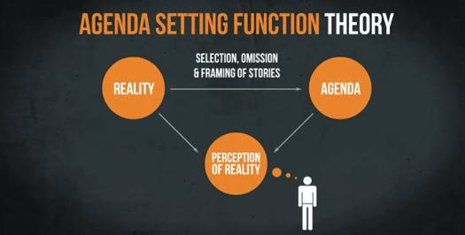](https://www.proprofs.com/quiz-school/story.php?title=3dq-agenda-setting-theory-of-the-media)

# Media Exposure

There have been many memorable events in media history that have changed laws and our personal beliefs for better or worse.

## Violent Content

Violent content has always brought up difficult conversations in media as some people think violence should be able to be displayed in videos or games. Whereas, others think violent content shouldn't be displayed. Parents especially believe this as they are overprotective of their children and believe that if their child comes in contact with violent media they will try to replicate it and grow up as a delinquent. This belief came into fruition with the first Mortal Kombat game which was placed in arcades open to the public, the Mortal Kombat series is known for showing extreme violence and blood. Due to how violent the game was parents outraged as the game was placed in arcades without being in an age restricted zone. Personally, I think violent content should be allowed in media although it would have to have an age restriction rating system similar to PEGI. However I also think with games such as GTA and Mortal Kombat, teenagers should be able to play it with their parent's consent as children exposed to these games will not replicate it as the hypodermic needle theory is false as I’ve mentioned previously in my work.

[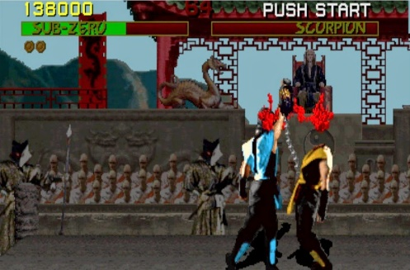](https://bristoliangamer.blogspot.com/2015/04/the-history-of-mortal-kombat.html)[](https://en.wikipedia.org/wiki/Pan_European_Game_Information)

## Advertising

Advertising is extremely useful in creating awareness for your product, most advertising is shown in media through images and videos as everyone consumes media on a daily basis. Advertisements can be very persuasive almost to the point of hypnotism which lulls audiences into purchasing their product through the use of many techniques that I covered in my work earlier like priming and agenda setting. I believe marketing is everything when it comes to selling a product well, as when it comes to Illumination Pictures business strategy they make low budget, unoriginal, average animated films that only sell well because Illumination pour all of their budget into the marketing as we all know because you’ve probably seen minions plastered everywhere too much for your liking. Although Illumination doesn’t put a lot of effort in their films they are the pros of marketing as they still rake in profits more than you could imagine even though their films are never critically acclaimed or put up for awards.

[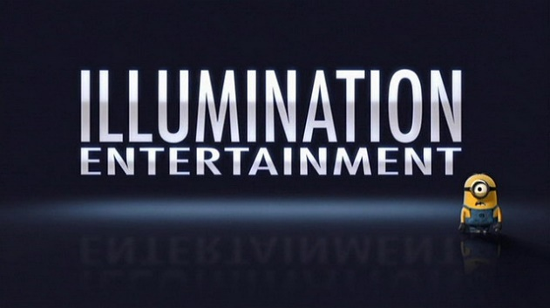](http://fantendo.wikia.com/wiki/Illumination_Entertainment)

## Fan Culture

Fans of a specific product or medium usually congregate to discuss and interact with each other about the product they love. You can have a fan base for anything as long as people like something they will usually talk about it. However, fan culture can veer off course from the usual interactions and discussions you would think to normally take place, this is where you would find unusual beliefs escalating into strange territories such as cosplaying and unorthodox original character drawings from televised shows, films or video games. Although this isn’t bad as the people taking part in this still love the product openly enough to publicly show it. On the other hand, fan culture can get a bad rap usually from sports fans as you can have football hooligans fighting enemy team audiences or even the unaware public through riots and vandalism.

[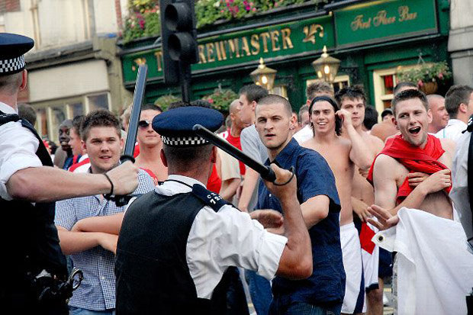](https://www.dailystar.co.uk/news/latest-news/627090/premier-league-football-hooligan-firms-west-ham-manchester-city-manchester-united-arsenal)

## Censorship

Censorship is when the media will hide information from their audiences for better or worse. An example of positive censorship is with how certain explicit scenes in Japanese animated shows are censored when viewed in the west as the original uncensored footage personally is too disturbing to my uncultured eyes which are not used to seeing these scenes in television. The censored scenes, however, will remove unnecessary violence and crop the screen to cover certain body parts for example like a bleeding stomach. An example of censorship that received a negative light is with the 4Kids dubbed version of the Japanese animated show called One Piece where they replaced a characters cigarette with a lollipop and replaced guns with water guns. Fans didn’t appreciate this change as they felt it went too far to make an action-adventure show seem to have no violence in retaliation fans started making fun of 4Kids for this change and stopped watching their dubbed version of the show and started watching a rival company’s version of the show.

[](https://www.theodysseyonline.com/5-changes-4kids-made-to-one-piece)

[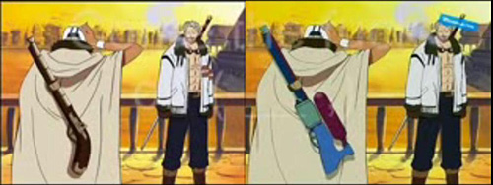](https://www.reddit.com/r/OnePiece/comments/480vvy/how_would_4kids_have_handled_the_marineford_arc/)

# Audience Survey

I made a Survey with Microsoft Forms to prove and disprove some media theories by sending this survey to my classmates and seeing if the answers correspond with the media theories presumptions on how people receive media.

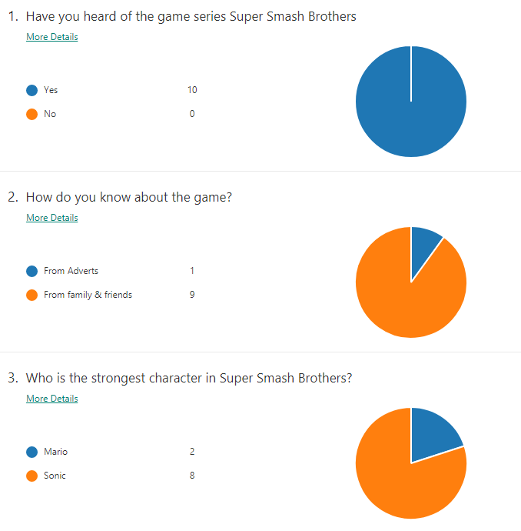

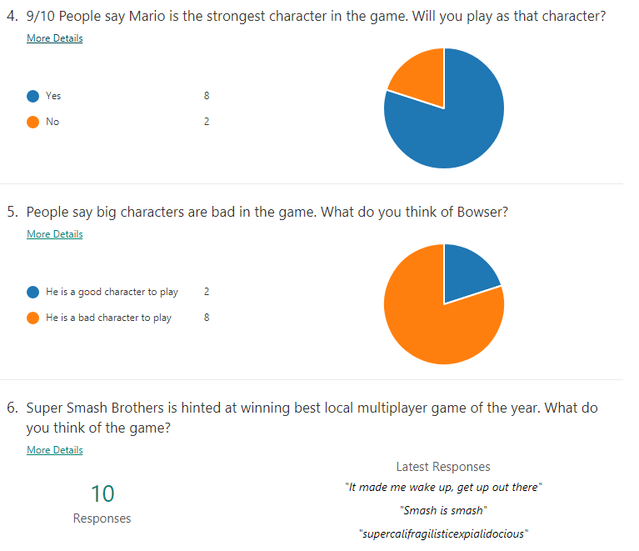

The first question was used to get rid of any anomalies as if anyone answered no to “Have you heard of the game series Super Smash Brothers?” I wouldn’t review their answer in my work.

The second question disproves the hypodermic needle theory as 90% of the responses stated that they heard of the game from family and friends and not directly from the media, as the hypodermic needle theory states that audiences acquire information directly from the media however the results of this survey suggest that people instead receive more information from influencers like family and friends proving the two step flow theory to be true.

Question 3 helps the agenda setting theory as I only put the options of 2 characters for the answer to “Who is the strongest character in Super Smash Brothers?” but there are a lot more characters in the game who could be stronger than the options I put. However the responders to my survey wouldn’t know this as I only gave the options of 2 characters meaning I can only get 2 answers so if I reported “Many people say Sonic is the strongest character in super smash bros” that would be true and untrue at the same time as I didn’t add all the characters in the game to my survey.

Question 4 was made to see if the spiral of silence theory is true and as I believe due to the results from the survey, it is. The spiral of silence theory says that people will go with the majority rather than the minority, as people unintentionally don’t want to be left out even if it is just a questionnaire and as most of the answers to “9/10 People say Mario is the strongest character in the game. Will you play as that character?” were “Yes” this means that they joined the majority of”9/10” proving the spiral of silence.

With question 5 I was trying to prove that the priming technique in media works by firstly saying that people think big characters in Smash play poorly and then I asked if they would want to play Bowser a big character thinking that if the priming theory works the answers to the question would be no and the majority were as no one wants to play a character they have just heard is bad. Question also helps the priming theory as I set up the question to get positive comments about the game by saying it is hinted at receiving an award, making people comment positive as after hearing that news you wouldn’t want to make a negative statement about that game.